Bishop’s Teaching Day 2018
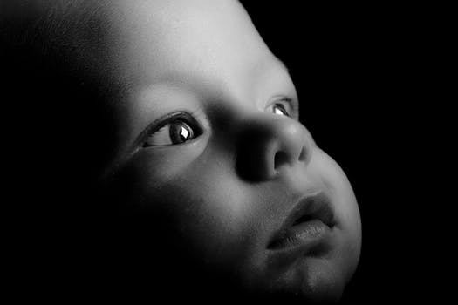

What Is Human?

A message from Bishop James:
This teaching day is part of our ‘God for All’ programme.
My previous Teaching Days have looked at the Gospel, The Bible, Prayer, Mission, The Church, the Kingdom of God, Evangelism, the Sermon on the Mount, The Old Testament, Discipleship and Christian Lifestyle.

This year I will continue the ‘What is …?’ series with an in-depth look at
‘What is Human?’ with sessions entitled ‘Who am I?’; ‘Why am I here?’ and ‘Where am I going?’

It will be particularly relevant to people’s questions about identity, self-worth and purpose in our lives. The aim is to build our confidence in the Christian faith, and it is intended to complement the teaching that already goes on so faithfully in our Parishes and Deaneries.

‘What is Human?’ will be offered in four locations (Carlisle, Workington, Kendal and Ulverston) and each day will last from 9.30 a.m. to 2.30 p.m.

Everyone will be most welcome.

Dates and Venues:

- Saturday 20th October St Mary’s church, Ulverston
- Saturday 3rd November St Thomas’ church, Kendal
- Saturday 17th November St Michael’s church, Workington
- Saturday 24th November St James’ church, Carlisle

To give us some idea of numbers it would be very helpful if you could please register your interest (stating which of the four events you will be coming to) by email to bhevents@carlislediocese.org.uk or by telephoning the Bishop’s Office 01768 773430.

What Is Human?

PROGRAMME:

9.30 a.m. Arrive

10.00 a.m. Session One: Who am I?

11.00 a.m. Coffee

11.30 a.m. Session Two: Why am I here?

12.30 p.m. Lunch break
Please bring your own lunch.
Drinks will be supplied.

1.20 p.m. Session Three: Where am I going?

2.20 p.m. Prayers

2.30 p.m. Depart

A CD of the Teaching Day will be available – if you would like to order a copy, please use the sign-up sheet provided at the venue, clearly printing your name, address, and telephone number.

The cost will be £5 per disc and payment should be made on receipt – payment details will be sent with the CD

