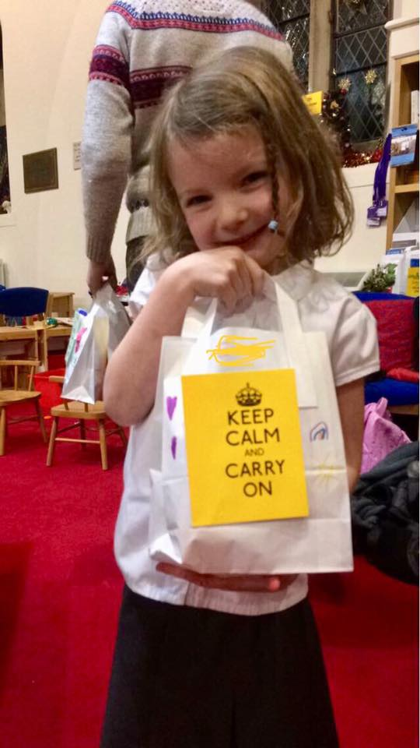
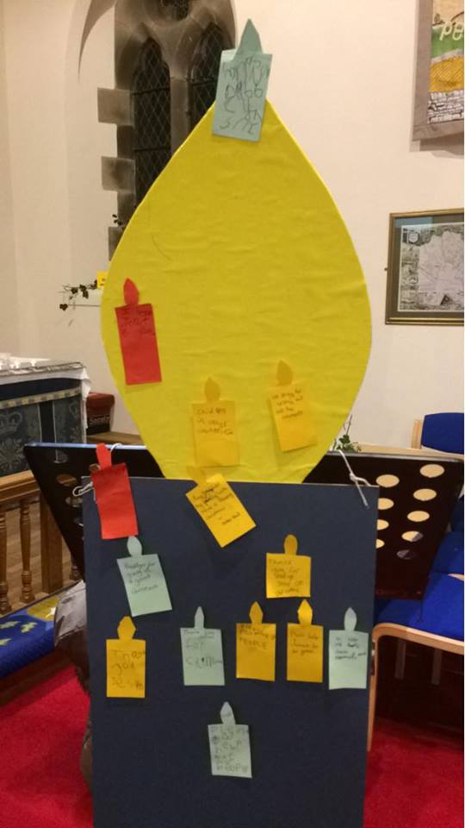
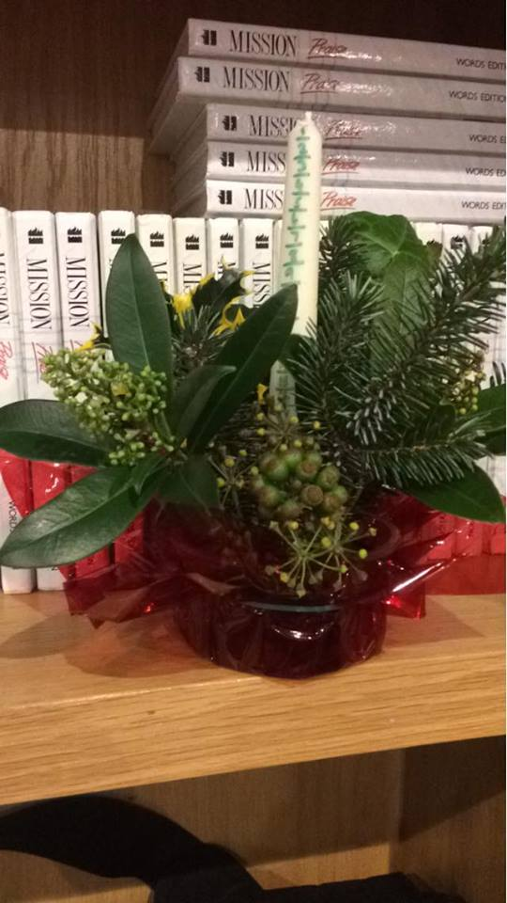

We love it when our friends at St. Mary’s Church run Messy Church after school for children and parents to go and be creative. This time the theme was all about a ’Stress less Christmas‘ and how we can pray to God to help us.

The children made advent candles, ‘Keep Calm’ bags for Mum’s, stress balls and tree decorations. Thank you Jean and her team.

